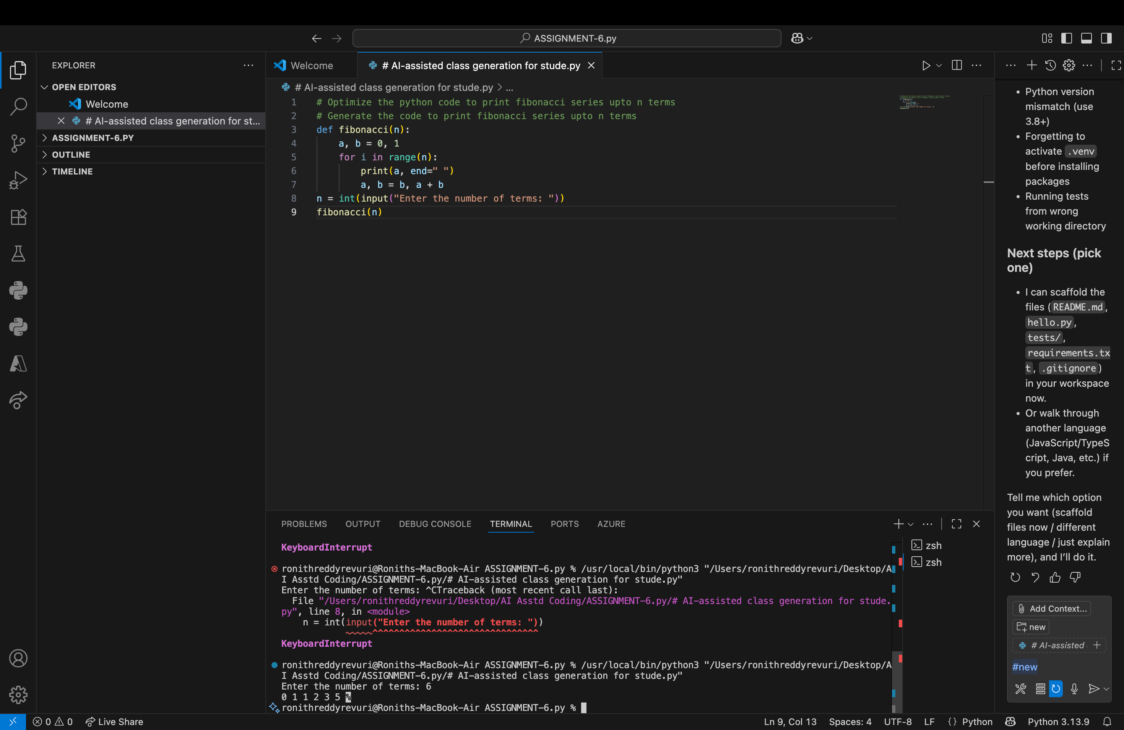
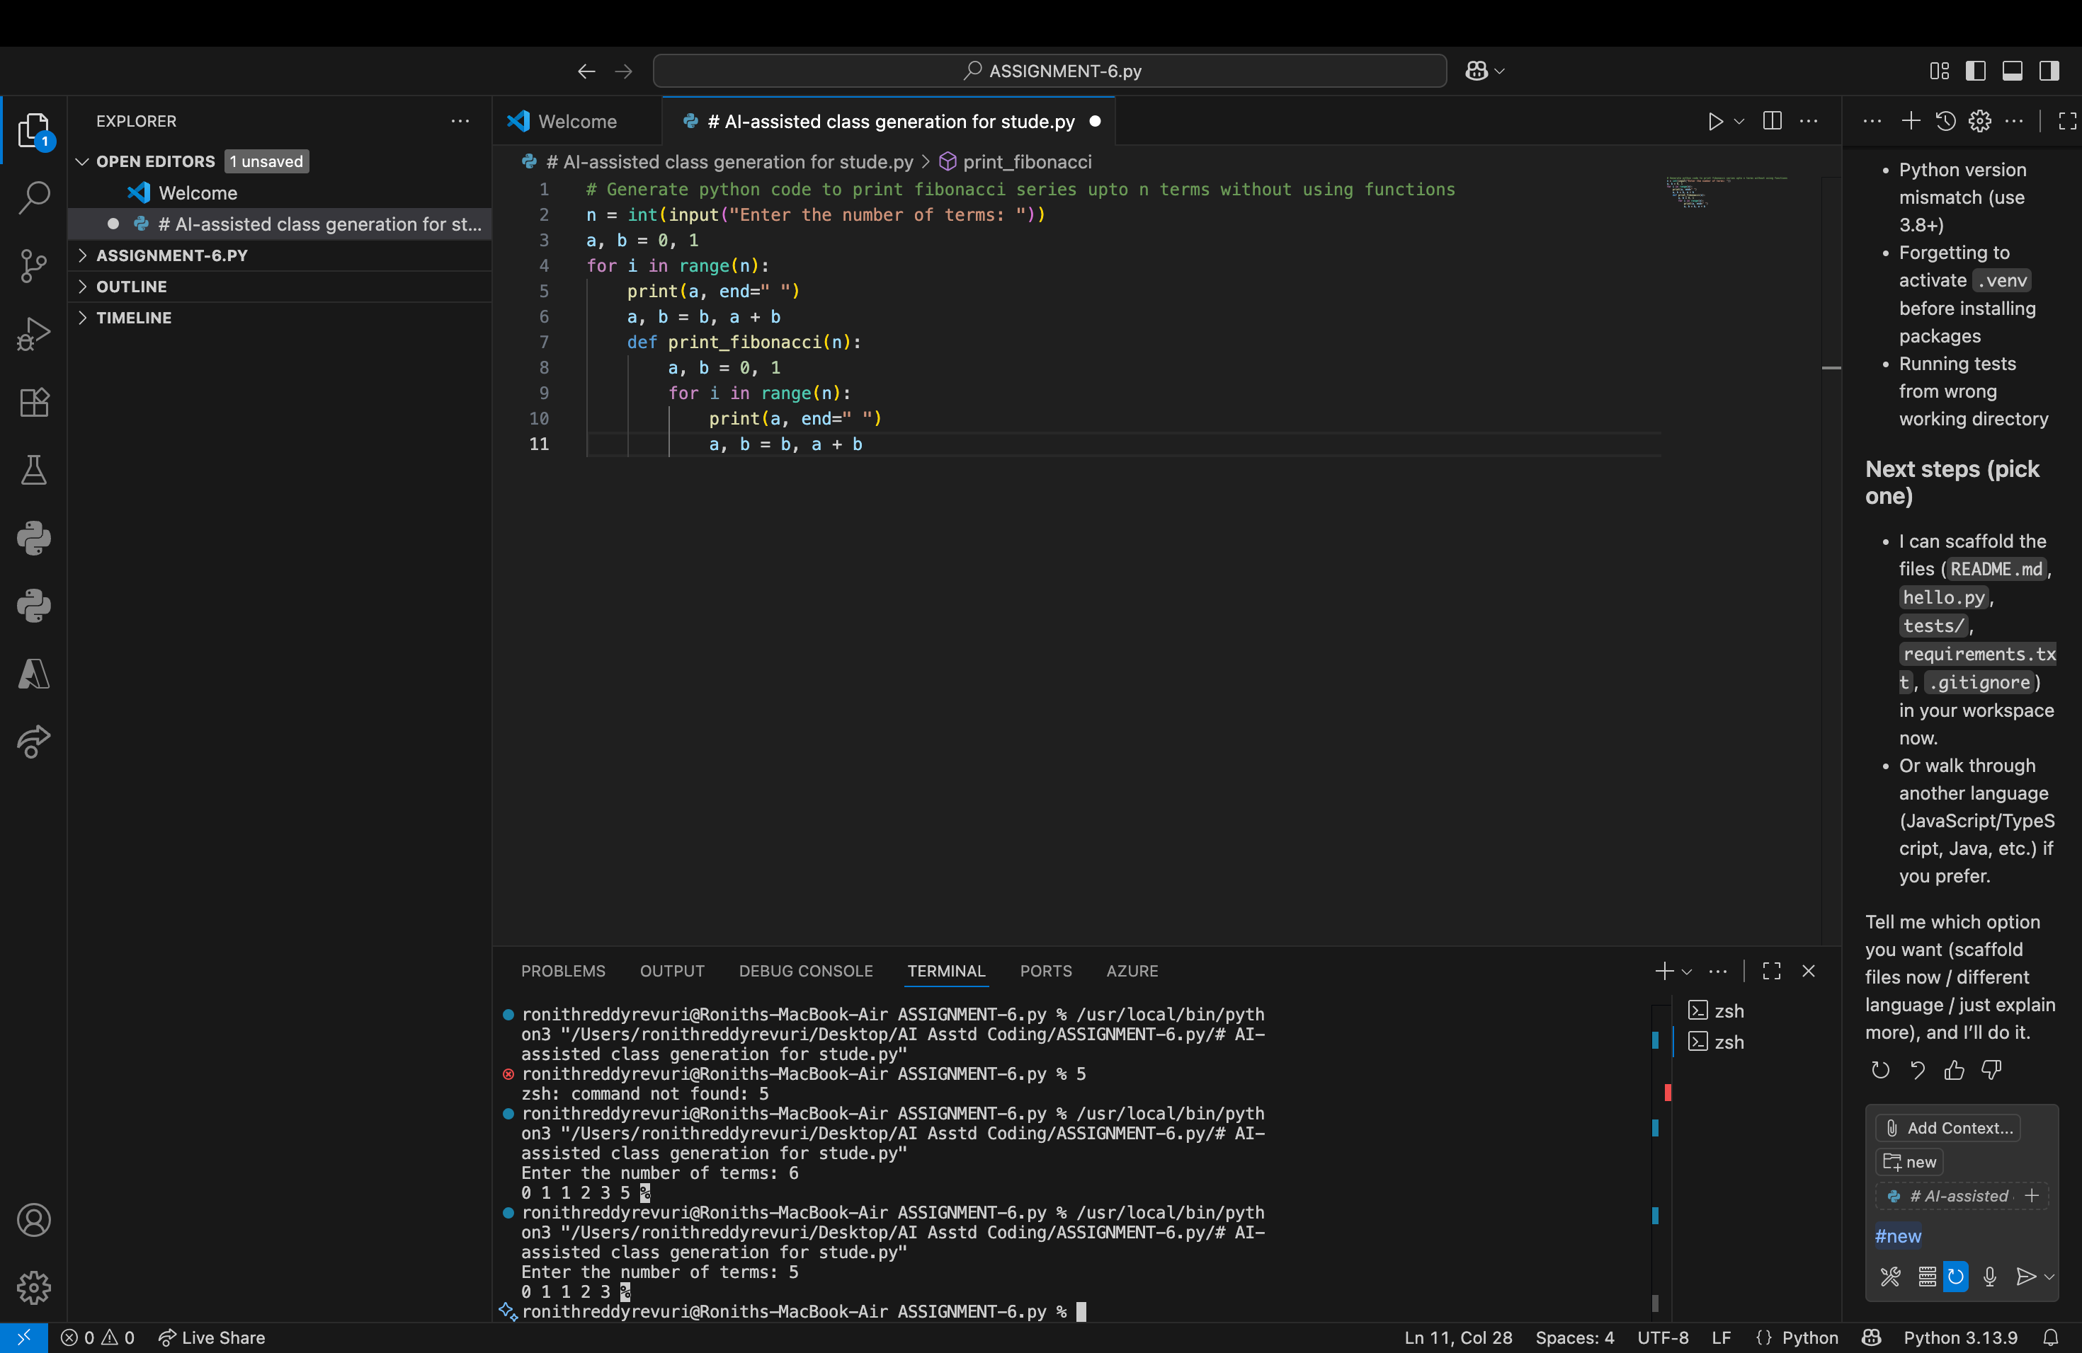
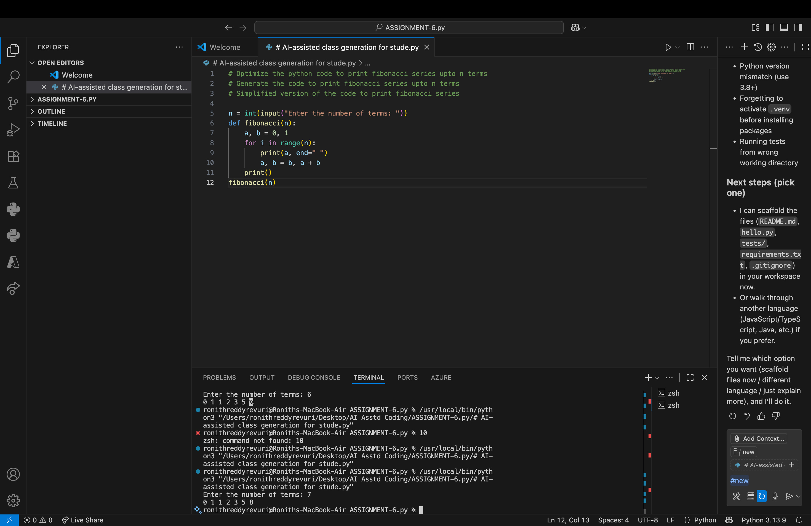
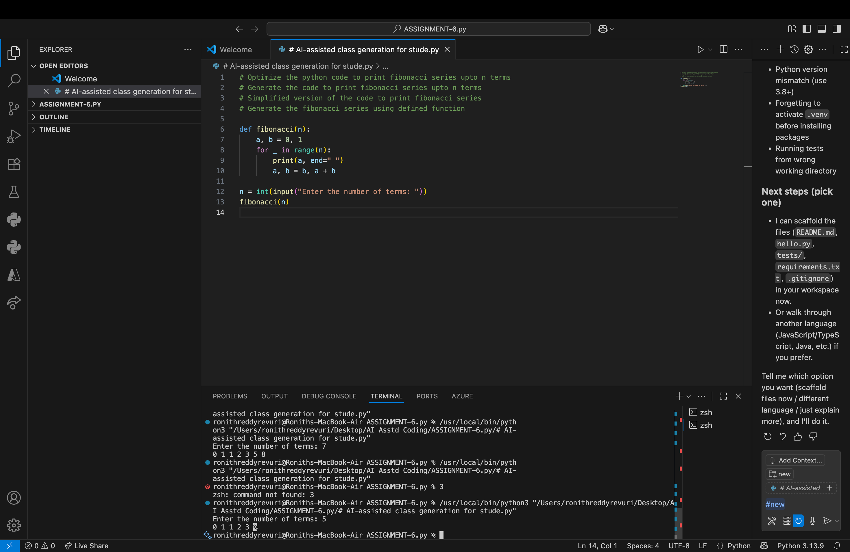
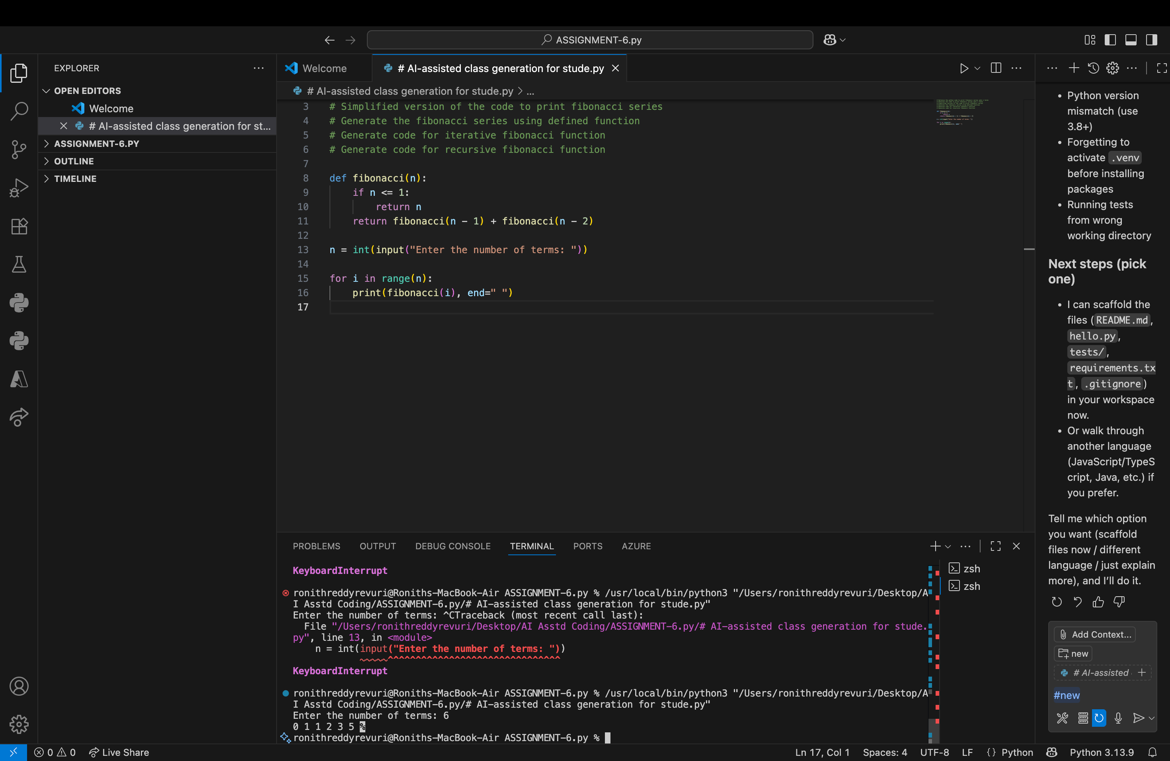
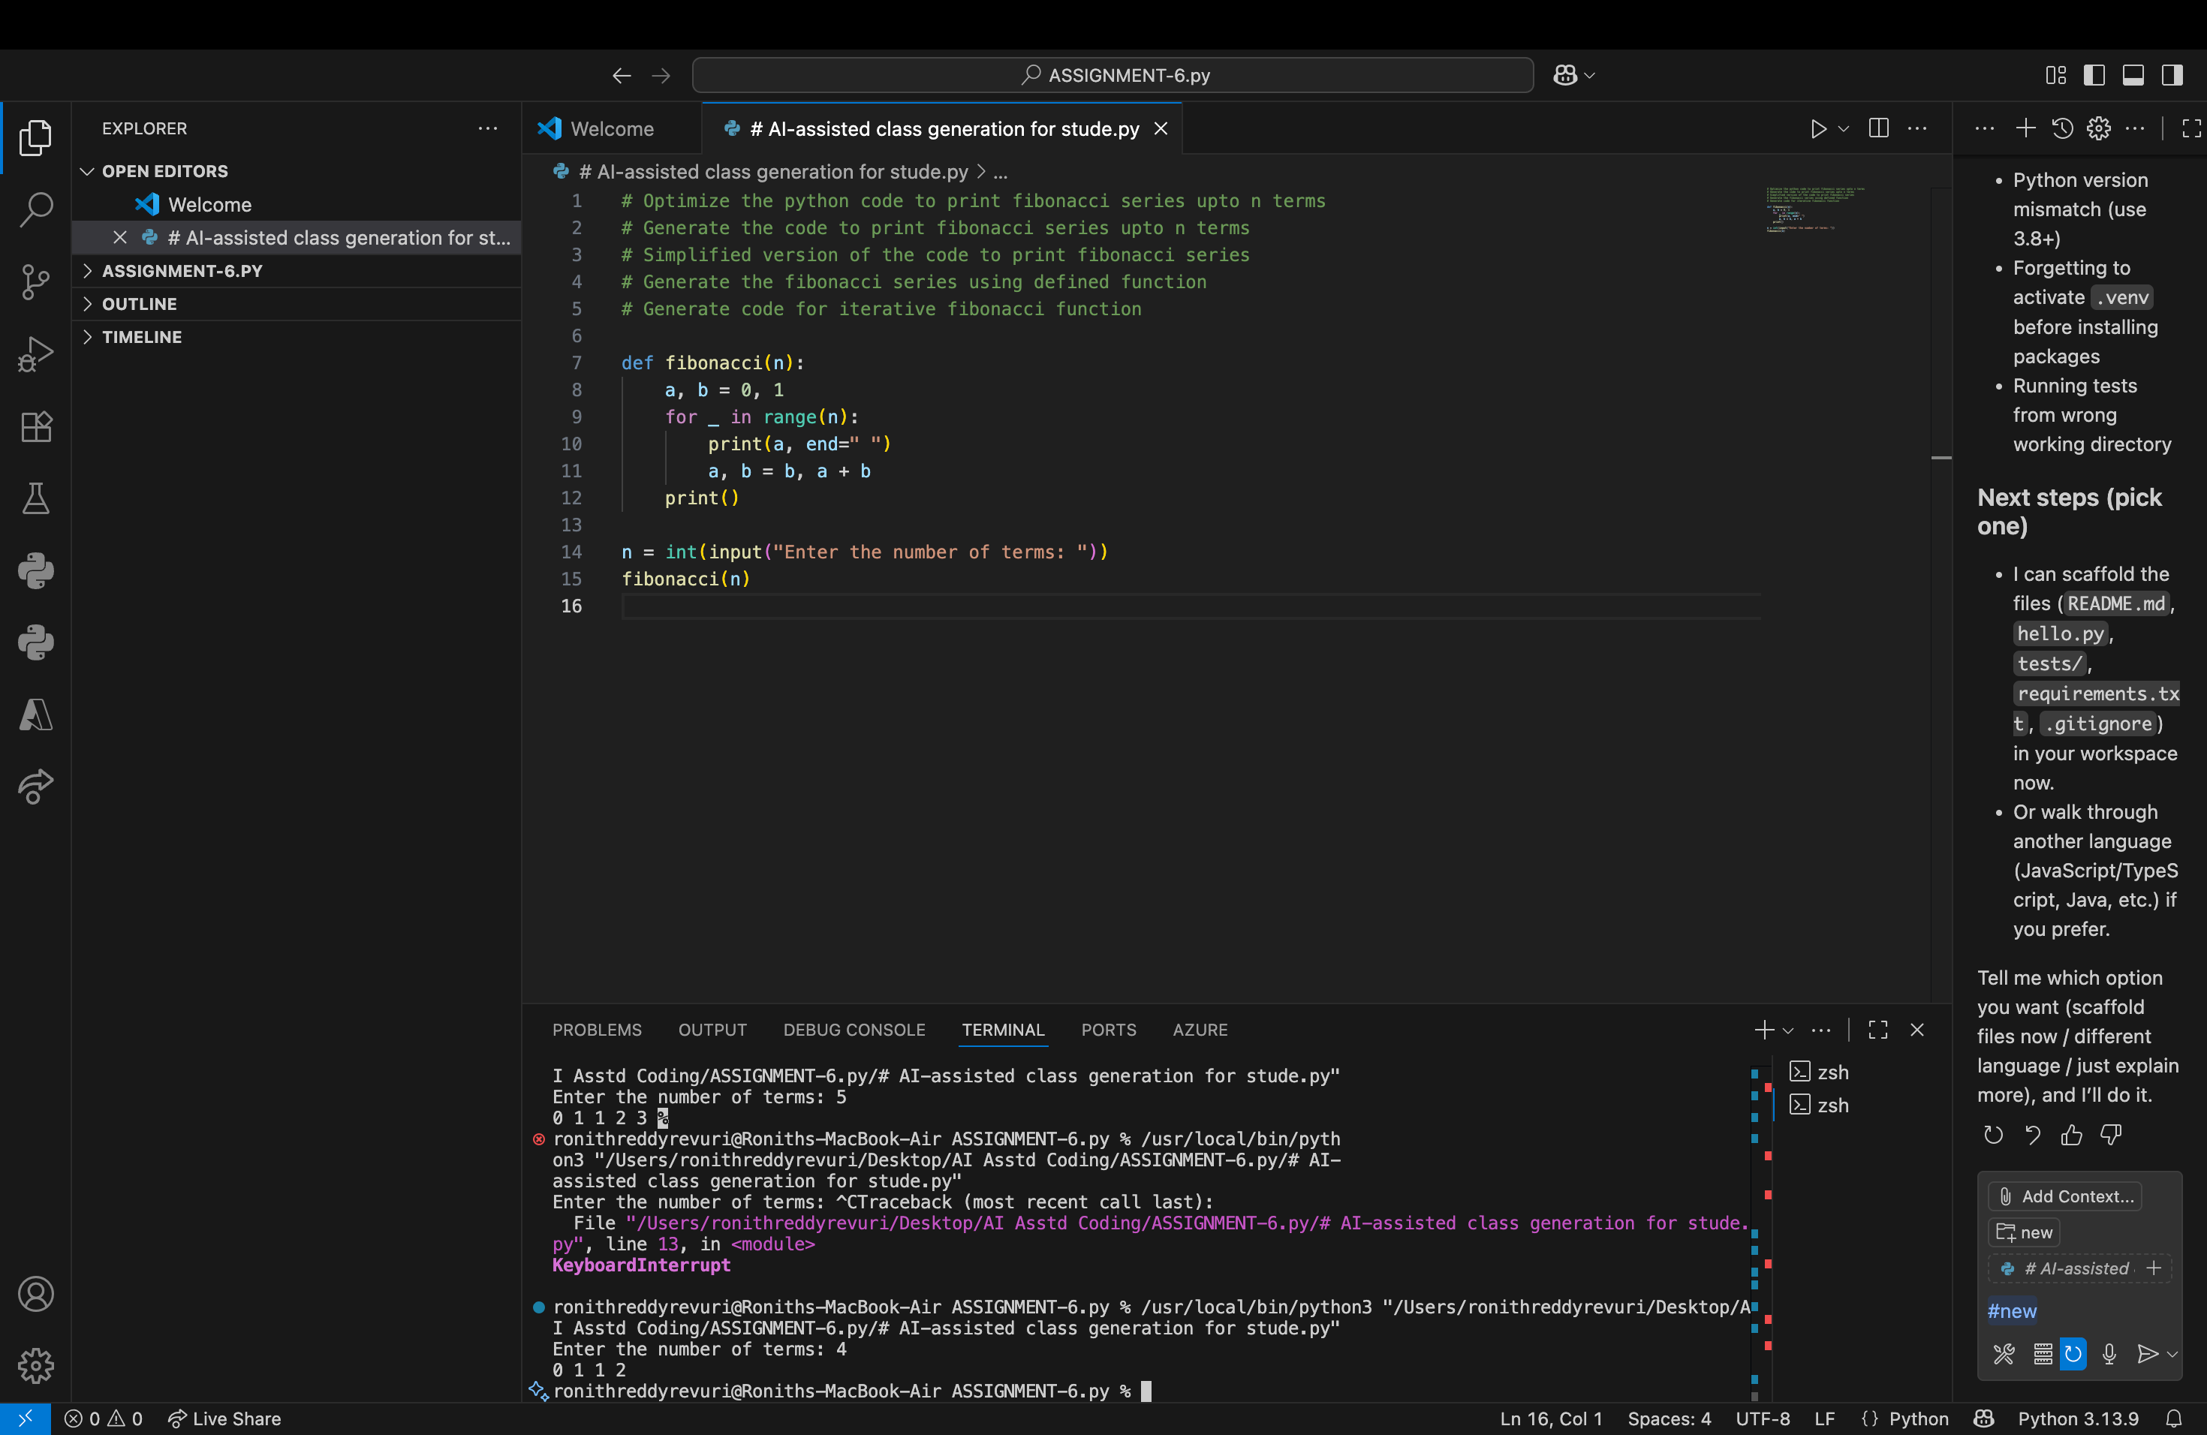
Time and Space Complexity Comparison
Abstract

The Fibonacci series is achieved through an iterative and recursive approach.

The iterative solution follows the loop mechanism with a time complexity of O(n) and space complexity of O(1). It is very fast with minimal memory requirement, making the solution efficient for large numbers too.

To be specific, in the recursive method, the function is called many times. As a result, the time complexity is O(2ⁿ) and the space complexity is O(n).

Conclusion

The iterative method is efficient and can be used with larger numbers, while the recursive method is inefficient and is not recommended for larger values of n.

